**CONNECTION TO TEACHING SERVER:**

For the purpose of demonstration, I am using MySQL Workbench on a Mac (10.14). You can use any other MySQL frameworks like heidiSQL (available for Windows) , PhPMyAdmin.

1. Download MySQL workbench from here: <https://dev.mysql.com/downloads/workbench/>
2. After installing the tool, Open new connection 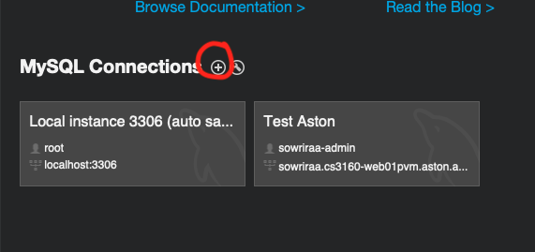
3. Fill in the details of the server name using the login credentials you received via email. See screenshot below for reference.

**Connection name** : Local instance 3306 (this can be anything)

**Hostname** : localhost

**Port** : 3306 (default)

**Username :** root

**Password** : set a suitable password

1. Test the connection by pressing the test connection button

NOTE : A nice and elaborate explanation is available on the NetBeans page for connecting to a MySQL database

<https://netbeans.org/kb/docs/ide/mysql.html>

1. In NetBeans, add the jdbc library and set up connections:

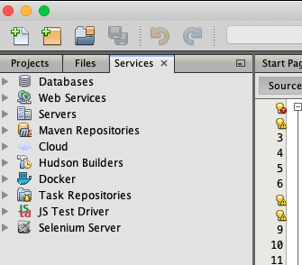

1. Right click on Databases -> New Connection:

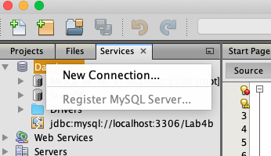

1. Fill in the details accordingly (see screenshot for sample ):

1. Test the connection to ensure everything is ok

1. Press Finish -> This should now be saved for the project.
2. Now the Connection URL will be something similar to this ( we need this to connect our Servlet), which can be found under the connection details:

jdbc:mysql://localhost:3306/mysql?zeroDateTimeBehavior=convertToNull